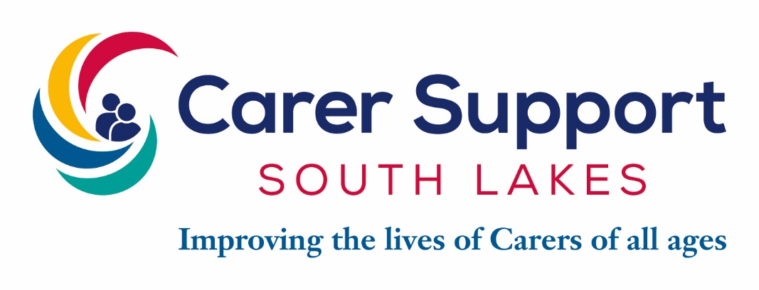
Improving the lives of all unpaid Carers
Our vision at Carer Support South Lakes (CSSL) is that every should
be able to live well and enjoy life feeling supported and included.

CONTENTS
- Job description
- Person specification
- How to apply and selection process

We are delighted that you are interested in joining our dedicated team at CSSL. We registered as a charity in 1993, and at that time provided a support group and supported 15 unpaid Carers. Today, 30 years on, we have evolved and now offer a range of services to support around 1700 unpaid Carers of all ages, from 5 to 100, throughout the South Lakes. The youngest Carer we support has just turned 5, and the oldest is currently 98. We are proud of the many achievements we have made since registering as a charity in 1993, and due to the dedication and hard work of our Trustees, staff, local supporters and many Volunteers. Our continued success depends on the contribution and expertise of every individual we employ and work with. We welcome and thank you for your application.

What we can offer you…

- Company pension
- 25 days holiday
- Birthday day off
- Telephone and Laptop provided
- Workplace Health & Wellbeing programme
- Westfield Health (quality health cover)
- Opportunities for PDP and progression
- Regular Lunch & Learns and staff social club
- Supportive work family

JOB DESCRIPTION

POST: Young Carer Support Practitioner
REPORTS TO: Lead Young Carer Support Practitioner
GRADE & SALARY: £22,767 FTE Pro rata
HOURS: 22.2 – Wednesday – Friday
LOCATION: South Lakeland- Kendal- Office based

MAIN TASKS & RESPONSIBILITIES

- Identify Carers and undertake a formal assessment of their individual needs in accordance with assessment criteria defined by Cumbria County Council Adult Social Care
- Formulate a support plan tailored to meet the Carers needs and responsibilities and encourage carers to make a contingency plan for emergency situation
- Provide telephone or face to face support for Carers requiring emotional support
- To establish and maintain all professional standard case notes on individual Carers and to complete all database requirements (both internal and external) for record keeping and monitoring.
- To work with all statutory and voluntary agencies and liaise with all health and social care professionals in support of the health and wellbeing of individual Carers.
- To work in accordance with the CSCP safeguarding protocol
- To develop and maintain links with Statutory Authorities and other agencies to raise awareness of Carers issues and their needs.
- To provide information and support to Carers, whilst promoting their independence.
- To refer or signpost Carers to other organisations which can provide services for the Carer
- To manage and support Carers groups
- To support in the delivery of trips, activities, residentials and social groups
- To attend carers events, meetings, forums and deliver presentations as required
- To carry out other such relevant duties as are required by this post.

ORGANISATIONAL REQUIREMENTS OF EMPLOYEES

- Carry out duties in accordance with legislative and regulatory requirements
- Carry out duties in accordance with CSSL policies and procedures, including Health and Safety, Confidentiality, Equal Opportunities and Data Protection
- Contribute to the overall achievement of CSSL mission and objectives
- Ensure the values of CSSL are upheld across the organisation
- Assist CSSL in Community Fundraising initiatives
- Promote CSSL social enterprise initiatives
- Participate in fundraising activities with and on behalf of CSSL
- Participate as part of the requirements of CSSL to meeting their ISO 9001 Quality Award standards
- Provide a supportive working environment to all staff and Volunteers
- Attend regular supervisions, staff and team meetings as requested
- Contribute to research and reports

This job description outlines the principal responsibilities and duties of the post holder. It is not meant to be, nor is it, an exhaustive list of specific responsibilities and duties. The post holder will be expected to undertake any other duties which could reasonably be expected as being within the remit of the post and which arise out of evolution as the organisation develops, changes of legislation, regulations, orders, rules and working practices, methods and procedures and reviews, as directed from time to time.
PERSON SPECIFICATION

ESSENTIAL | DESIRABLE
Qualifications
- Good education attainment at Secondary School  - English and Maths Grade A-C | - Relevant qualification or training in Health and Social Care/ Social Work/ Nursing at level 3 or above
Experience of
- Working directly with Carers  - Working on own initiative  - Working and communicating with staff and colleagues from partner agencies including GPs, Social Services etc.  - Multi-disciplinary working | - Working with or within the voluntary sector  - Working with / in the health and social care services and community provision  - Experience of working with Adult and Children’s Social Care Integrated Assessment System (IAS/ICS)
Knowledge
- Understanding of issues affecting carers such as long-term disabilities and illnesses- in particular Young Carers  - The Care Act – Carers Assessments and Care Support Needs Assessment for people they care for  - Good working knowledge of other assets, services and organisations within South lakes to support Carers and the people they care for  - Relevant legislation including H&S and Mental Capacity Act  - CSCP Safeguarding Protocol | - The work of Carers’ Associations  - The work of Social Services in relation to Carers and the Cared-for  - Welfare Benefits  - National Care Standards
Skills
- Excellent written and verbal communication with a wide range of audiences  - Demonstrate strong interpersonal and influencing skills  - IT literate (Microsoft) in particular, managing database  - Excellent communication skills  - The ability to prioritise and organise under pressure | - Excellent presentational skills  - Knowledge of fundraising  - Line management responsibilities
Qualities
- Ability to relate to Carers and Cared-for  - Ability to plan, work and organise under pressure to work on own initiative and as part of a team  - Commitment to Equal Opportunities, Cultural Diversity and exceptional customer service  - Ability to manage own professional and personal development and a willingness to learn  - The ability to relate to and empathise with Carer’s and the people they care for  - Ability to drive and have access to a car | - Ability to respond to new situations  - Ability to communicate well written reports

TO APPLY FOR THIS POSITION

You must complete an application form, Rehabilitation of Offenders Act 1974 (Exception) Order 1975 form and equal opportunities monitoring form available to download from the CSSL website www.carersupportsouthlakes.org.uk in Word and PDF formats. You may attach a letter but please don’t send photographs. We do not accept CVs.

If you don’t have Internet access, telephone 01539 815970 and give us your name and address, quoting the job title and reference number.

In completing your application, you must tell us how you meet the essential qualification, experience, skills and qualities outlined in the Job Specification.
We will assess how you meet them through the application form and interview. We will let you know if we will include a presentation or a skills test if you are selected for interview.

DEADLINE FOR RECEIPT OF APPLICATIONS
This vacancy closes Friday 1st March 2024. Forms received after this time will not be processed.
Your completed application form, Rehabilitation of Offenders Act 1974 (Exception) Order 1975 and equal opportunities monitoring form should be returned by one of the following methods:

By email:
Please email admin@carersupportsouthlakes.org.uk. There is no need to send additional copies. If successful, you will be asked to sign your electronic application form at interview. Please note that our email servers will not accept emails larger than 10MB.

By post:
Holly Cragg (Operations Manager)
Carer Support South Lakes,
Beezon Annex, Beezon Road, Kendal, Cumbria LA9 6EL

ACKNOWLEDGEMENT OF RECEIPT
Email applications will be acknowledged when we receive them. Should you wish to receive an acknowledgement for a postal application, please include a self-addressed envelope with a 1st or 2nd class stamp and we will return this to you.

INTERVIEWS
Interview date TBC

